Planning a Computer Project

Student ID: 22210016

Instructor Name: Dr. Islam Alomari/ Eng. Asma

HTU Course No || BTEC Unit Code: 40201290 || H/618/7407

Academic Year Summer 2023/2024

Contents

Project Management Plan 1

1. Scope Management Plan 1

2. Time, Cost, and Resources Management Plan 5

3. Change Management Plan 11

4. Risk Management Plan 12

Project Recommendation and Justification 16

## Project Management Plan

### 1. Scope Management Plan

#### 1.1 Project Requirements

* **1.1.1 Project Functional Requirements:**
  + The company should have a website with an AI-powered section that can analyze big data from user interactions on the website and social media, travel dates, seasons, most popular places and trends accurately that will help suggest and organize travel schedules that are suitable for travelers and connect solo travelers with each other based on their interests.
  + The system will perform a user authentication system when the user logs in to be secureand then after logging in a verification email must be sent to users upon registration to ensure that the information is correct and belongs to them., and the system includes a strong protection system for users’ personal data through encryption and preventing unauthorized access.
  + The site should provide real-time recommendations to travelers and website users, taking into account important factors such as current location and planned travel route and similar and shared interests. The system should update the suggestions dynamically as new data is received.
  + Equipping fully secure servers to store sensitive traveler data, which will increase in size many times over after the promotions.
  + The system should collect user feedback after each travel experience in order to improve the matching algorithm and future recommendations. This feedback should be analyzed to improve the accuracy of the AI ​​model and user satisfaction.
* **1.1.2 Project Non-Functional Requirements:**
  + The AI model must process traveler matching requests within 06 seconds, that make sures a seamless user experience. Also the system should be scalable to handle increasing user loads, maintaining a response time of under 3 seconds even with over 10,000 simultaneous users.
  + In order to make sure about the user data privacy and security all data processing and storage and transmission must comply with relevant data protection regulations, here we should also the data protection officer and chief information security officer must make sure that the employee those who work under them are well trained.
  + The system should maintain 99.9% uptime, and also make sure t that users can access the service whenever they do needed. the redundancy measures should be in place so it can handle server failures or unexpected downtime.
  + The systems' user interface should be visceral and accessible and it should providie a seamless experience across various device's and as weIl as platforms. It must also be accessible to users with disabilities and complying with relevant accessibility standards.

#### 1.2 Scope Statement (What)

The main aim of this project is to create a smart system for Tourstify that uses AI to understand what solo travelers like and connect them with others who have similar interests. The goal is to make travel more fun for people who travel alone by suggesting travel buddies with the same likes. The system should be able to handle more users as the business grows, without slowing down or crashing. It also needs to keep all user information safe and private. We want to make the website easy to use on any device, and we need tools to help us monitor how the system is working and to train our staff on the new technology. The success of the project will be measured by how well the system connects travelers, how fast it works, how secure it is, and the feedback we get from users and staff. We plan to have the system fully working within 12 months, starting with AI development, then focusing on the website design, making sure it scales, securing it, and finally testing everything. This project is possible to do because we have a good team and we’re determined to make it work, helping solo travelers enjoy their trips more and helping Tourstify grow.

*The In Scope:*

* Using Ai to understand wht travelers like and what habits they make.
* Connecting solo travelers with others where they sare the same interest.
* The system that is develop should be scaled well as users increase.
* There should be a user interface for the staff so they can review the matches and suggestions.

*The Out Scope:*

* Generat an advertisements for customers.
* Updating the website content with new offers that is catchable for customers.
* Creating a complete fraud detection system.
* An advanced analytiss for targeting marketing campaigns.

#### 1.3 Objectives (Why)

Our objectives cover all aspects of the project, including system functionality, user satisfaction, and adherence to timelines and budget.

|  |  |  |
| --- | --- | --- |
| PROJECT OBJECTIVE | PROJECT BENEFIT | SUCCESS METRIC |
| Build an AI-based matching system | Helping solo travelers connect with others who share similar interests, making their travel experiences better and more fun. | AI system that matches travelers based on their interests, with an accuracy of at least 90%. |
| Develop a scalable system that grows with user demand | making sure that the system can handle a growing huge number of users without slowing down or crashing. | Keep a response time of under 3 seconds, even with over 10,000 users in the same time. |
| Make sure that data is secure and private | Protect all users important informations and build trust | Succeed 99.9% uptime and compliance with all relevant data protection regulations. |
| Provide a user-friendly interface | Make the system easy to use and improving user experience across the website. | The user should give positive feedback, with at least 93% of users finding the interface easy to navigate. |
| A feedback loop for continuous improvement | Allow users and staff to provide real-time feedback. | More than70% of users actively providing feedback, wich lead to regular updates and improvements to the system. |
| Train the staff on new technology | makeing sure that staff can efficiently use the new system | more than 80% of the internal staff completing training sessions, and they are confident with the system. |

#### 1.4 Work Breakdown Structure (WBS)

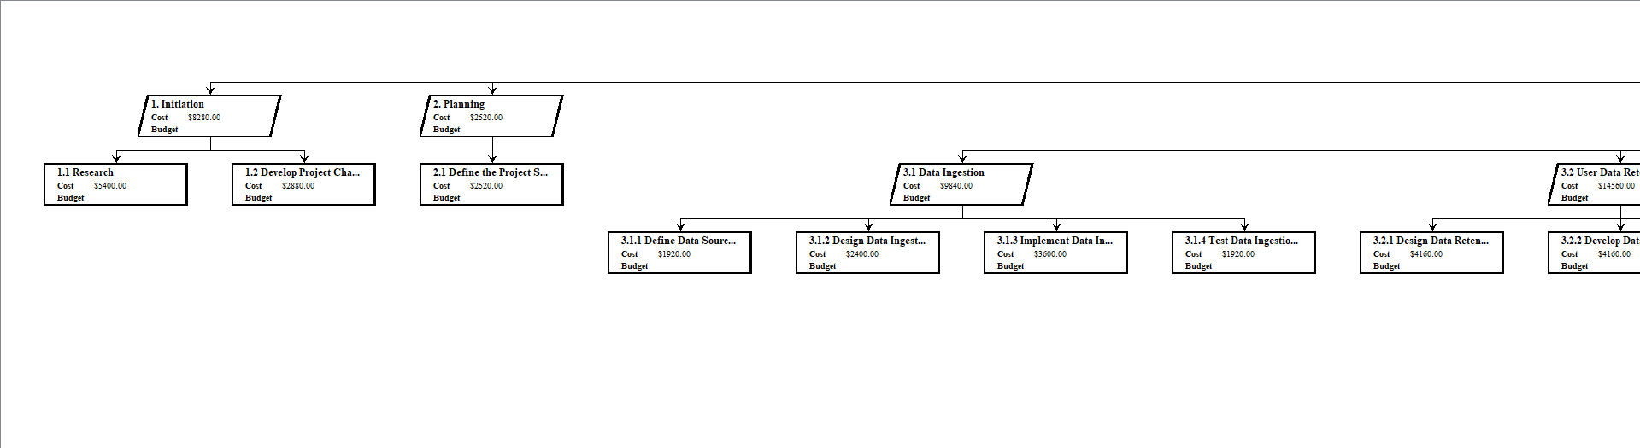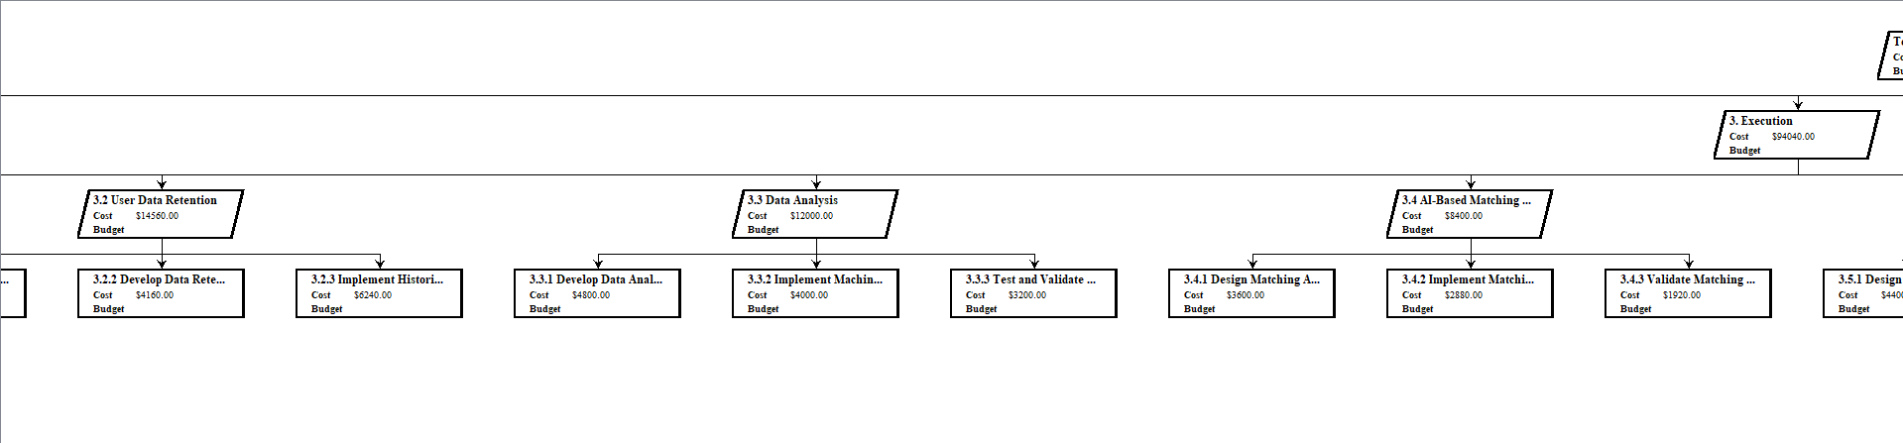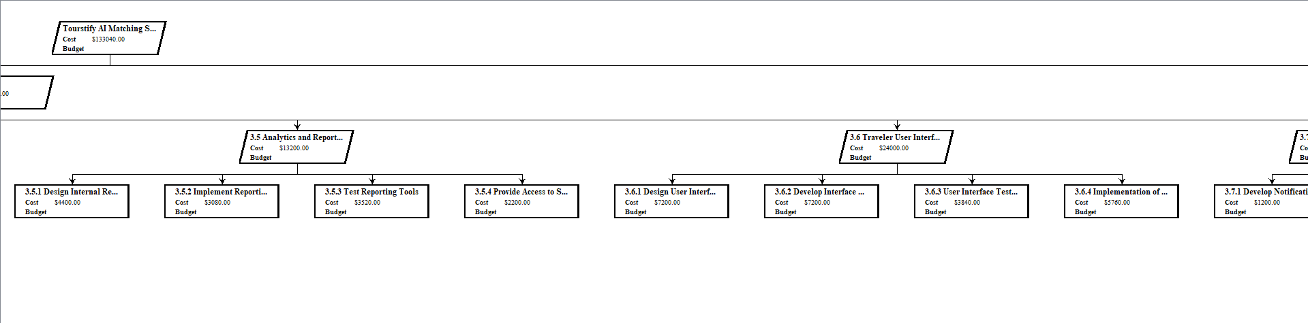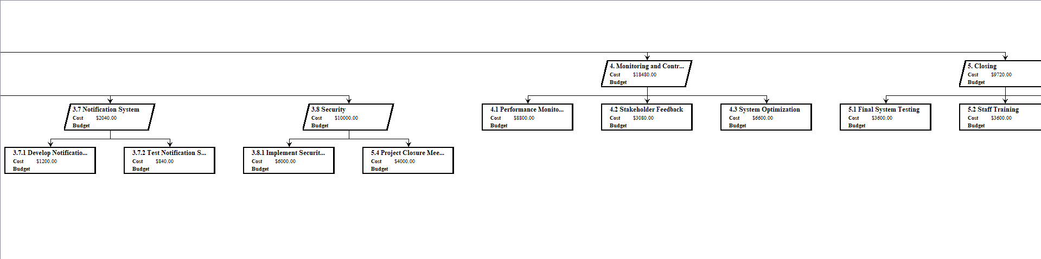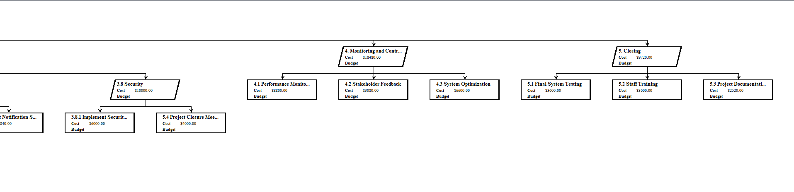

We start with the main goal, which is to build the Tourstify AI Matching System, and then split it up into different phases, like Initiation, Planning, Execution, Monitoring and Controlling, and Closure. Each phase is then further broken down into smaller tasks, like developing the AI model, designing the website, making sure everything is secure, and training the staff. By breaking everything down like this, it helps us see all the steps we need to take and make sure we don’t miss anything important. Plus, it makes it easier to assign tasks to the team members and keep track of progress. The WBS is like a roadmap for the project, showing us how to get from start to finish in a organized way.

#### 1.5 Milestones (When)

|  |  |  |
| --- | --- | --- |
| DATE | MILESTONE | DESCRIPTION |
| 10/8 | Milestone 1 | Project Initiation Complete: It marks the completion of the project initiation phase which includes the research and the development of the project charter and it shows that the project has been ready to proceed. |
| 29/1 | Milestone 2 | Data Ingestion System: It marks the completion of the data ingestion phase from data collecting and defining its source to designing and implementing the ingestion process and then testing, so I will know that the sytem can start recieving and processing data. |
| 26/5 | Milestone 3 | AI Matching Algorithm Implemented: Finishing the AI matching system code including its implementation and the validation of algorithm that I used for the matching. |
| 23/7 | Milestone 4 | User Interface and Notification System: Completing the user interface and the notification system and checking the security in the website for all the users, whether they was the travelers or the employees who use the website. |
| 10/28 | Milestone 5 | Closure and Handover Complete: In the final we should make sure that the entire project have finished and has been tested successfuly, and also staff training, and project documentation, so the system now is ffully operational and ready for regular use. |

### 2. Time, Cost, and Resources Management Plan

#### 2.1 Gantt Chart

In the Gantt chart, the key components include tasks, durations, dependencies, resources, and milestones. The Gantt chart will illustrate how time, cost, and resources align with each phase of the project. Milestones such as data collection, AI model development, and system integration will be plotted that is going to help and make the tracking for the progress more clear.

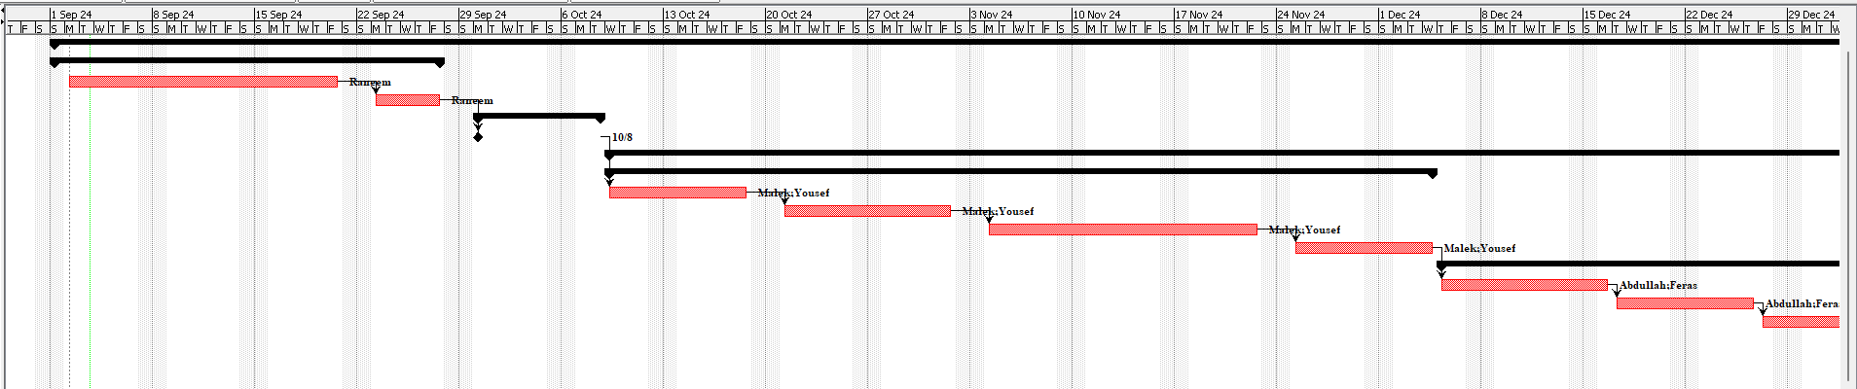

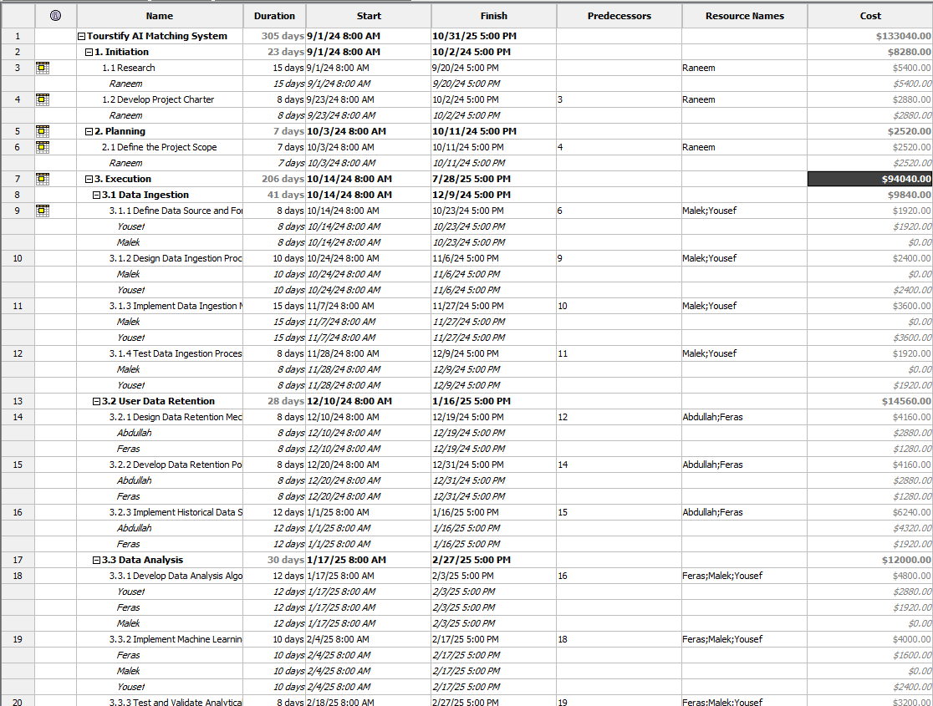 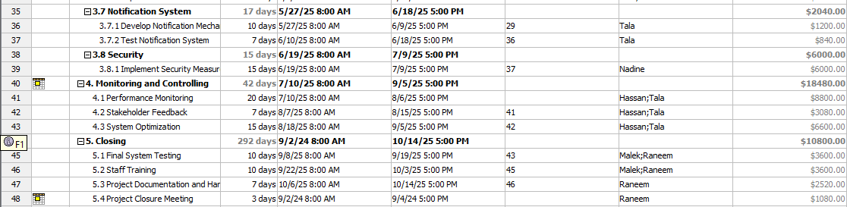

The ganttchartt I made for the project includes all the task and the resources needed for each and as shown also the cost for each task, These tasks from the project I divided them into the most important phases for projects Initiation, Planning, Execution, Monitoring and Controlling, and Closure. So lets start first with the initiation which takes 20 days to finish and that because the research will took from Raneem 15 days to be completed and for the project charter 5 days wold be enough to finish and it will cost 7200$ for Raneem cause she takes 45 per hour. This task is important because it sets the foundation for the project and helps define its goals and scope. The research helps gathering necessary information while the project charter outlines the project"s objectives and stakeholder's. Now going to the planning phase 30 days was enough to define the scope for the project and and its going to cost 10800$, I put a lot of time for it because I believe that good planning will help in lowering the possibility of unforeseen setbacks while executing out the project and the planning phase sets the stage for successful execution and helps manage stakeholder expectations, and after all these tasks I have finished the first milestone in my project.

In the execution phase, which is the longest part in all the project to took 196 days and costs 90040$, several tasks are involved starts with Data Ingestion which took 41 days and its going to cost as 9840$, where Malek and Yousef work on defining the data source and format which took 8 days and its going to cost as 1920$ and Malek acctualy is an intern he is learning from Yousef who is an expert, designing the data ingestion process which took 10 days, and its going to cost as 2400$, implementing the ingestion mechanism which took 15 days, and its going to cost 3600$, and testing all this the process which took 8 days, and its going to cost as 1920$. This task is important because it sets up the foundation for data management in the project. It is going to make sure that all necessary information is collected and organized properly which is realy important for the success of the AI-based matching system.

User Data Retention follows which took 28 days, and its going to cost 14560$, involving Abdullah and Feras in designing the data retention mechanism which took 8 days, and its going to cost 4160$, developing data retention policies which took 8 days, and its going to cost 4160$, and implementing historical data storage and which took 12 days, 6240$. This task is realy important for maintaining user information securely and in compliance with data protection rules. It also make he system able to use historical data that is going to help in improving matching algorithms all over time. Data Analysis is next it took 30 days, 12000$, with Feras, Malek, and Yousef developing data analysis algorithms which took 12 days, 4800$, implementing machine learning models which took 10 days, 4000$, and testing and validating analytical models which took 8 days, 3200$. This task is also important for the project as it forms the core of the AI-based matching system. It involves creating and refining the algorithms that will power the travel recommendations, making it a key component of the projects success.

The AI-Based Matching System task which took 35 days, 8400$ has Hiba and Malek designing the matching algorithm which took 15 days, which going to cast as much as 3600$, implementing it which took 12 days, 2880$, and validating matching recommendations which took 8 days, 1920$. This task is the heart of the project as it creates the system that will match travelers with suitable destinations, It"s accuracy and effectivieness will directly impact user satisfaction and the overall success of the platform. Analytics and Reporting which took 30 days, costing 13200$ is handled by Hassan and Tala, who design internal reporting tools which took 10 days, 4400$, implement the reporting mechanism which took 7 days, 3080$, test the reporting tools which took 8 days, costing 3520$, and provide access to stakeholders which took 5 days, 2200$. This task is important for monitoring the system"s performance and providing valuable insights to stakeholders. It helps in making datasdriven decisions and improvement's to the platform.

The Traveler User Interface task which took 50 days, 24000 includes designing the user interface which took 15 days, costing 7200$, developing interface functionality which took 15 days, 7200$, testing the user interface which took 8 days, 3840$, and implementing the interface which took 12 days, 5760$, with Hiba and Raed as resources.The Notification System task which took 17 days, costing 2040$ involves Tala developing the notification mechanism with 10 days, 1200$ and testing the notification system which took 7 days, costing 840$. This task is important for keeping users informed and engaged with the platform, enhancing the overall user experience.

Security which took 15 days, 6000$ is handled by Nadine, who implements security measures. This task is critical for protecting user data and ensuring the integrity of the system, which is essential fo building trust with users and complying with regulations. The monitoring and controlling phase spans 42 days and costs 18480$, with tasks like Performance Monitoring spends 20 days, costing 8800$, Stakeholder Feedback which took 7 days, costing 3080$, and System Optimization it took 15 days, costing 6600$ carried out by Hassan and Tala. This here is realIy important for making sure that the project stays on track and meets quality standards and adapts to any changes or issues that appears during execution.

Finally, the closure phase which took 30 days, 10800$ includes Final System Testing which took 10 days, costing 3600$ by Malek and Raneem, Staff Training which took 10 days and going to cost 3600$ by the same team, Project Documentation and Handover which took 7 days, costing 2520$ by Raneem, and the Project Closure Meeting which took 3 days, costing 1080$ with Raneem. This phase is crucial for ensuring the system is fully functional, properly documented and successfully handed over to the operations team, It also provides an opportunity to reflect on the projects successes and lesson’s learned.

Actually the budget that Tourstify got for the project is really good and high that make them able to employee the best employees every and using the most good resources in the project and for the employees the whole project is going to cost 137320$.

#### 2.2 Critical Path Analysis

1.1 Research

1.2 Develop Project Charter

2.1 Define the Project Scope

3.1.1 Define Data Source and Format

3.1.2 Design Data Ingestion Process

3.1.3 Implement Data Ingestion Mechanism

3.1.4 Test Data Ingestion Process

3.2.1 Design Data Retention Mechanism

3.2.2 Develop Data Retention Policies

3.2.3 Implement Historical Data Storage

3.3.1 Develop Data Analysis Algorithms

3.3.2 Implement Machine Learning Models

3.3.3 Test and Validate Analytical Models

3.4.1 Design Matching Algorithm

3.4.2 Implement Matching Algorithm

3.4.3 Validate Matching Recommendations

3.5.1 Design Internal Reporting Tools

3.5.2 Implement Reporting Mechanism

3.5.3 Test Reporting Tools

3.5.4 Provide Access to Stakeholders

3.7.1 Develop Notification Mechanism

3.7.2 Test Notification System

3.8.1 Implement Security Measures

4.1 Performance Monitoring

4.2 Stakeholder Feedback

4.3 System Optimization

5.1 Final System Testing

5.2 Staff Training

5.3 Project Documentation and Handover

5.4 Project Closure Meeting

This represents the sequence of tasks that is directly impact the overall project duration. Any delay in these tasks will cause a delay to the entire project. This path is going to begins with **Research** and **Develop Project Charter**, setting the foundation for the projects goals and scope. Next then we are go defining the project scope to make sure tthat all subsequent tasks are aligned with the projects’ objectives.

The critical path then flows into data_related tasks, including defining the data source and format, designing and implementig the data ingestion process and testing the ingestion mechanism. Each of these steps is crucial for ensuring that the system can effectively handle and process data, which is fundamental to the project's success.

After the data ingestion, attention shifts to designing and implementing data retention mechanisms and developing the analytical models that will drieve the system's intelligence. The matching algorithm's design, implementation, and validation are also on the critical path, as they are core components of the system's functionality.

Internal reporting tools and security measures are also vital, ensuring that stakeholders can access insights and that the system is secure. The path concludes with performance monitoring, stakeholder feedback, system optimization, final testing, and staff training, which are essential for ensuring that the system meets all requirements and is ready for handover and deployment.

#### 2.3 Cost Estimate (Budget)

I chosed the salaries based on each persons’ experience and what they bring to the team. For example, Nadine is realy good at her job and always delivers high-quality work, so her salary is the highest at $50/hour with a secondary rate of $23/hour. Raneem and Abdullah both have a lot of experience and responsibeility in their roles, which is why they also have a higher salary of $45/hour and $20/hour for secondary tasks. Yousef and Hiba are also valuable team members, and they help mentor others, so their rates are $30/hour and $15/hour for secondary tasks which is realy goood.

Feras is a bit newer to the team but still plays an important role, so his rate is $20/hour with a lower secondary rate of $10/hour. Hassan has a good mix of experience and skills, so his rate is $40/hour with $17/hour for secondary tasks. Tala is still learning and has less experience because shes still fresh-graduate, which is why her rate is $15/hour with no secondary rate.

But here we have Malek is an intern and heis here to learn, so his internship is unpaid. He spends a lot of time with Yousef and Hiba to learn from their experience. So all the salaries are set to reflect each persons contribution to the team and their level of expertise.

### 3. Change Management Plan

#### 3.1 Awareness

To make sure everyone knows about the new Solo Travelers AI Matching System, we will keep people updated in simple and easy ways. We will send emails that explain what the system do a when it will be ready, and how it will help travelers. We will also hold short online meetings to talk about the system and answer any questions people might have. In addition there will be notifications inside the app that remind users about the new features, so they is always in the loop. We want to make sure everyone understands how this system can improve their travel experience by finding other solo travelers with similar interests.

#### 3.2 Readiness

We know that not everyone is tech-savvy, so we will provide clear and easy training to help users get ready for the new system. We will create simple guides that show step-by-step how to use the system, so even beginners can follow along. There will be webinars where users can see how the system works live, and they can ask quastions if they is confused. These sessions will show how to find matching travelers, how to set preferences, and how to make the most out of the system. We will also set up customer support to help users who might still have trouble, so they never feell lost. The goal is to make sure everyone feels comfortable and confident using the new system.

#### 3.3 Resilience

Here in ordeer to make sure the Solo Travelers AI Matching System is ready for everyone, we will do a lot of testing before it goes live. We will invite some users to try the system early and give us their feebdack, so we can fix any problems’ before the full launch. After the system is launched, we will have a special support team ready to help with any issues that come up. If users have questions or find something that doesnt work right, this team will be there to fix it quickly. We want the transition to be smoooth, so users can start enjoying the new features without any worries.

### **4. Risk Management Plan**

#### **4.1 Risk Types**

|  |  |  |  |  |  |
| --- | --- | --- | --- | --- | --- |
| **Risk Type** | **Risk name** | **Risk** | **Scenario** | **Mitigation Plan** | **Response** |
| Security | R1 | Data Breach | Unauthorized access to sensitive data while we was making a testing. | Implement advanced encryption and access controls. | Risk Mitigation |
| IT (business continuity) | R2 | System Downtime | Unexpected downtime during testing a part from the system usage. | Set up redundant systems and regular maintenance. | Risk Avoidance |
| Finance management | R3 | Budget Overrun | I needed some data about cities from a government source, but it wasn't available so I had to buy it from a private company. | Try not to spend a lot of money so I will bargain. | Risk Mitigation |
| Data Quality | R4 | Data Accuracy | Inaccurate data that was a leading to poor decision-making. | Implement data validation processes and continuous monitoring. | Risk Mitigation |
| Security | R5 | Security Vulnerabilities | Potential security loopholes in the system. | Conduct regular security audits and patch vulnerabilities promptly. | Risk Mitigation |
| IT infra structure | R6 | Physical | Hardware damage due to environmental factors which is a fire when there was an increasing in the temperature. | Install physical protections and have backup hardware in a secure location. | Risk Avoidance |
| IT | R7 | Data Loss | Loss of data due to a mistake the intern make in the system. | Implement regular backups and disaster recovery plans. | Risk Mitigation |

#### **4.2 Probability Chart**

|  |  |  |  |
| --- | --- | --- | --- |
| **Probability** | **Risk name** | **Qualitative** | **Quantitative (if measurable)** |
| Low | Budget Overrun | The possibility of it happening is **very rare**. | 0.01% During the whole project |
| Security Vulnerabilities | Because the company cares about security, it is **impossible** for this to happen. | 0.08% During the whole project |
| Data Breach | **Rare**, because of the high security. | 0.1% During the whole project |
| System Downtime | **Impossible, unless** the trainees make unexpected mistakes. | 0.05% During the whole project |
| Medium | Physical | **Possible** due to electrical faults causing device malfunctions | 8% During the whole project |
|  |  |  |
| Data Loss | The probability of its occurrence is slightly higher than the other.  **Possible** | 10% During the whole project |
| High | Data Accuracy | **Likely**, depends on how the data was collected. | 25% During the whole project |
|  |  |  |
|  |  |  |

#### **4.3 Impact Chart**

|  |  |  |
| --- | --- | --- |
| **Impact** | **Risk name** | **Impact Description** |
| Low | |  | | --- | |  |   - | - |
| - | - |
| - | - |
| Medium | Data Loss | Data loss will cause major problems because the foundation of the company depends on data, and this will lead to the disruption of its work. |
| Budget Overrun | It will affect the reserve budget, potentially reducing it by 10% to 50%, reducing profitability, potential project delays, need for additional funding. |
| Data Accuracy | Having low data accuracy will result in incorrect results which may affect the suggestions the system provides to users. |
| High | Data Breach | Hacking and theft of private data will lead to legal penalties for the company and a loss of trust from customers. |
| Security Vulnerabilities | It can lead to the theft of information belonging to the company and its customers. |
| System Downtime | System downtime will result in disasters, lost revenue and dissatisfied customers. |
| Physical | It will lead to service interruption, financial losses and possible data losses. |

#### **4.4 Probability and Impact Matrix**

|  |  |  |  |
| --- | --- | --- | --- |
| **Probability/Impact Matrix** | **Impact** |  |  |
|  | Low | Medium | High |
| **Probability** |  |  |  |
| High |  | **R4** |  |
| Medium |  | **R7** | **R6** |
| Low |  | **R3** | **R2**  **R5**  **R1** |

**5. Software Development Methodology**

I choosed Agile for this project. Agile is good when you deal with big data and AI models because it let us build things little by little and change things as we go. With Agile, we split the work into small bits, called sprints, where each sprint is going to works on a different part of the project.

Lets say for example, in one sprint, we might get the data ready, make sure it’s clean and in order. In another sprint, we can focus on making the AI model that match solo travelers with similar interests. Then, in a later sprint, we test how good the AI model works and make it better if needed. Each sprint is like a small loop where we plan, design, build, test, and launch one part of the project.

This way of working is really useful cause it let us get feedback from users early and fix things fast if something’s wrong. Like, if users get confused by the matching system, we can change the design or improve the AI without waiting for the whole project to be finished. Doing things in small, easy steps make sure the system always fits the project needs, even if those needs change.

Agile also helps us stay flexible, which is super important in a project like this wheere tech and user wants might change. Instead of getting stuck in a long hard process, Agile let us turn and change direction whenever we need to keeping the project on the right path and close to our goals.

The Agile way also pushes for working together, so the whole team can be close, share ideas, and solve problems when they come up. This make sure every part of the system from cleaning the data to refining the AI model to putting everything togetherworks well together, giving the users a smooth and good experience.

### **Project Recommendation and Justification**

#### **1. Methods and mediums to communicate with the stakeholders**

|  |  |  |  |  |  |
| --- | --- | --- | --- | --- | --- |
| **Stakeholder name** | **Stakeholder role** | **Stakeholder type** | **Methods or mediums** | **Frequency** | **Justification** |
| The Project Manager ‘Badar’ | Internal Coordinator | Internal | Weekly Meetings it might be an online meeting or face to face with the managers for the sections in the company. | Weekly | Ensures consistent updates and alignment with project goals. |
| CTO ‘Yousef’ | Technical | Internal | He weekly face to face meets with the IT team to seee their progress and helping them in many tasks | Weekly | Allows for real-time troubleshooting and technical discussions.  And he also see the It team progress and helpis them in hard tasks. |
| Customers  ‘Sara’ | System Users | External | She use our services from our website from one years, she always gives positive feedback in the feedback section in the website. | Monthly or more duration. | Giving as information and feedback about how the users are satisfied with our services. |
| Ministry of Tourism in Jordan | Compliance Monitoring | External | Formal Reports | Quarterly | Ensures that the project adheres to industry regulations and standards and that they are enhancing the tourism in Jordan. |

#### **2. Arguments for Planning Decisions**

The planning decisions I made for this project idea were based on a deep understanding I did of what Tourstify needs to achieve and the most effective and efficient ways to reach those goals to make the project success. The choice of the Agile methodology was in its place, as it provides the flexibility needed to develop the AI system in an iterative manner, allowing for adjustments' and improvement's based on real user feebdack and changing requirement's. This approach makes sure that that the project is not locked into a rigid plan,' but can adapt when better solutions apperes during the development process. also thee cost estimates were meticulously planned to ensure that every aspect of the project, from data processing and system development to unforeseen expenses. I also included a contingency buffer because we understand that things dont always go as planned and we need to be prepared for the unexpected things that might maybe happens. The deliverables were designed not just to complete the project but to also make sure that the AI matching system is accurate efficient and userfriendly. cuccess metrics have been clearly defined I will measure the systems' effectiveness in matching travelers and its ability to handle increasing user volumes without performance issues and its effectiveness in safeguarding user data. In addition to these technical metrics, we will also assess user satisfaction and the completion rate of employee training as key indicators of success. The impact analysis indicates that this project will not only meet Tourstify’s immediate objectives but also lay the groundwork for long_term growth by making solo_travel more enjoyable and personalized..

#### **3. Project Recommendations**

The project plans have been done with Tourstify's good needs in mind, trying to make a system that meets now wants while also being good for the future. The suggested money has been planned very carefully to make sure that all the important parts of the project are covered, from AI work and website size to security plans and worker teaching. This money is not just about paying for things but about putting money into a system that will make customers happy and, as a result, help the business grow. The time line has been made to allow for a good process of work that includes many tests to make the system strong before it starts. We has made sure there ares enough time to fix any problems that may happen during the work, without rushing and messing up the quality. The risk plan is active, finding possible problems like data security worries, system size issues, and possible model mistakes. By making clear ways to deal with these risks, we are ready to handle these risks well, lowering the chance of them messing up the project. However, we're also realistic and know that unexpected problems can happen, so we've put in flexibility to change our plans as needed. The change plan is full, making sure that all workers are well prepared for the new system through clear talk, good teaching, and ongoing help after it starts. This will help to make the change smooth and reduce any problems in daily work. Overall, these plans are made to make sure the project stays on track, within the money, and lined up with Tourstifys bigger goals of making customer experiences better and encouraging new things in the travel field.

This project has the chance to not only met but go past expectations, making Tourstify a leader in the travel area. also we need to keep putting money into advanced AI tech to keep making better ways to match travelers and guess their likes. This could mean using machine learning that gets smarter over time based on user actions, helping the system become better and more right in its ideas. Also, we suggest trying AI-driven things like unique travel plans and changing prices to offer travelers special experiences. by staying up to date on the latest AI new things and putting them into our system, Tourstify can make sure its system stays latest, driving both customer happiness and long term business growth. Keeping an eye on future AI changes and by puting them into our system will help Tourstify stay ahead and keep being a leader in the travel field.

#### **References**

* *What is a Milestone in Project Management?* (no date). <https://www.wrike.com/project-management-guide/faq/what-is-a-milestone-in-project-management/>.
* GeeksforGeeks (2023) *6V’s of big data*. <https://www.geeksforgeeks.org/5-vs-of-big-data/>.
* Dovetail Editorial Team (2023) *Thematic Analysis: A Step-by-Step Guide*. <https://dovetail.com/research/thematic-analysis/#:~:text=in%20qualitative%20research%3F-,Thematic%20analysis%20is%20a%20method%20of%20analyzing%20qualitative%20data.,identify%20common%20patterns%20and%20themes>.
* Nikolaieva, A. (2022). *8 Best Software Development Methodologies*. [online] www.uptech.team. Available at: <https://www.uptech.team/blog/software-development-methodologies>.
* Hartshorne, D. (2020). *A no-nonsense guide to critical paths*. [online] monday.com Blog. Available at: <https://monday.com/blog/project-management/critical-paths/>.